P160509v1

FP 22268 - Batch Print Controller (BPC) Interface
A Batch Print Controller (BPC) will manage the timing and sorting of Workticket printing. The BPC can be configured to run at a user defined regularly scheduled interval. The lab can configure a System Option “Print at RX Entry?” that activates this feature.
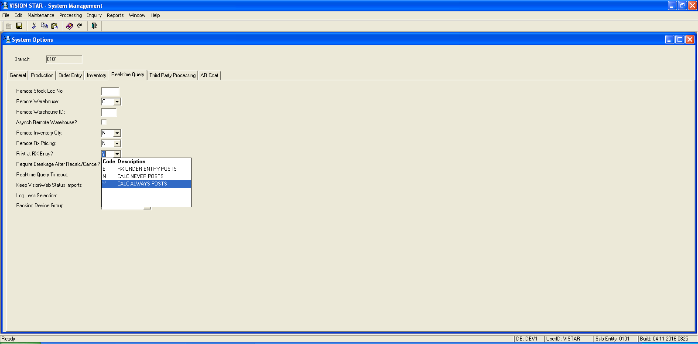

Based on options set in the controller BPC (“Print at RX Entry?” = “Y”) the lab will be able to configure the combinations of order to include in the BPC. The 2 options “E” RX Order Entry Post and “N” Calc Never Posts. When the “E” option is set only imported orders will use Batch Print. Hand keyed orders will print immediately. When the “N” option is set both Imported and Hand Keyed orders will use Batch Print. The lab will be able to select from one of the following sort options: Frame Bin, Lens Bin, Lens Material, Lens Style, Material + Lens Style, Lens Style + Material, Frame Vendor and Frame Vendor + Frame Name.

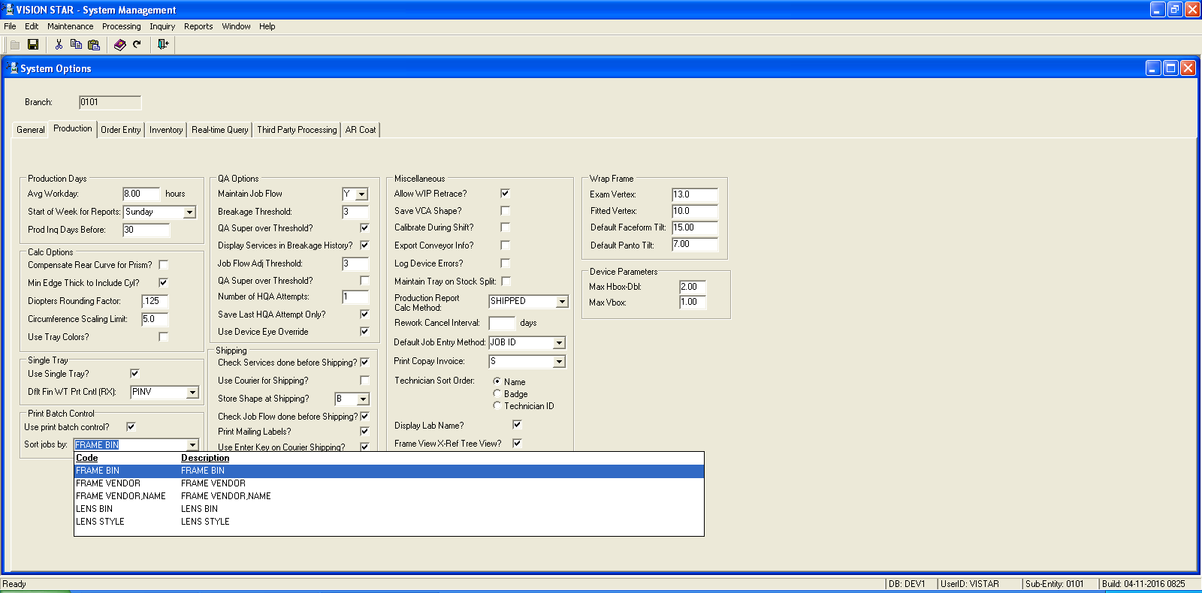

FP 25568, 26740, 26502, 27810 – Auto recalc on retrace (trace99)
A number of labs have requested that we revise the procedure the system uses to attachment of new frame tracings from a tracer to a work-in-process order. The basic idea is that:

- When a new shape is attached to an existing job that is not in process (ie status of RECEIVED or RECALC), a “reshape-needs-recalc” ticket will print, on a printer near the tracer. This will be done by an Oracle procedure producing postscript output, since rxspool cannot process jobs in this state.
- When a new shape is attached to an in-process job that has had lenses verified, if the finish layout change is within tolerance based on the MAXX and MAXY values set on the tracer interface the main workticket will be re-printed, with revised shape and layout, at a printer near the tracer.
- When a new shape is attached to an in-process job that has had lenses verified, and the change in finish layout is outside the lab’s defined change tolerance based on MAXX and MAXY values set on the tracer interface, a “reshape-error” ticket will print, also on a printer near the tracer. This ticket, printed using rxspool, can contain the new shape drawing/layout. After printing, the job will be put into RECALC status, similar to the way digital calc errors are handled.
- When a new shape is attached to an in-process job that has NOT had lenses verified, then:
The job will be put back into RECALC status regardless of the amount of finish layout change, and the job will be recalculated automatically. If it succeeds, the normal work ticket will print (but at the printer near the tracer); but if there are any errors or warnings then the job will remain in RECALC status and a reshape-needs-recalc ticket will print.

This new process needs to be configured in order to work. All tracer interfaces must have a MAXX and MAXY configured and the printer / printer control for the reshape-needs-recalc ticket must be specified. Since the printing of a ticket is now available with this feature a dedicated printer will need to be in place to print the work ticket or recalc ticket. This should be setup near the tracer so the ticket can be found easily by the tracer operator and placed in the tray.

FP 25606 - Problem with the date of the "FR" docs

Procedure pkgar_post_inv.post_inv_to_ar was using the old method for determining if an invoice was a consolidated invoice. It was looking at the first two characters of the invoice id for a FC. It now looks at the doc_type value for an CI. Resolved issue to correctly calculate the due date for consolidated invoices using the document type CI.

FP 25714 – New Digital Lens configuration setup for all sub entities

Automatically create configuration setups for all sub entities when creating new configuration setup. When creating the following for all sub entities will have identical records created.

1. Create Vendor

2. Create vendor configuration

3. Create engraving mask for vendor

4. Create custom engraving mask for customer with vendor engraving mask.

System Management/ Maintenance/ Direct Surfacing:
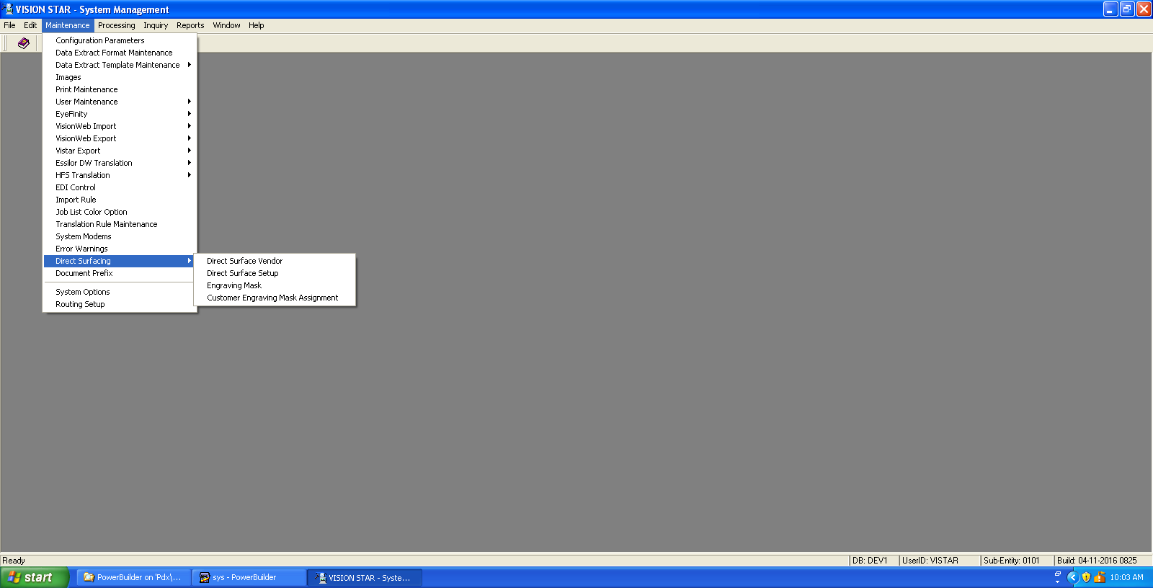

FP 25715 - Order routing between labs
The outsource process now supports outsourcing between labs on the same database between entities (internal / intercompany). This will allow the receiving lab to send an order to a different production lab for some piece of production the way it would for an external lab. The production lab order will be independent of the receiving lab order.

FP 25765 - ART Blockers Issue
When blocking fails, correctly identify the XSTATUS of “E” from the blocker. When this happens don’t store the blocking information for the job.
FP 25871 - Blue Tech Lens Report
Created new Blue Tech Lenses export file report summarizing lens sales. Database app Maintenance / Lenses / Lens Product Report Groups / Lens Report Groups

FP 26192 - Order Data Extract ignores selected User Entity
Original code was not picking up and passing User Entity to Order Data Extract procedure. Modified procedure call to ensure entity value gets used.

FP 26521 - Dynamic and Static Shipping Bins
Make Dynamic and Static Shipping Bins / Boxes work together. When using both, include:
- When assigning a dynamic ship box, do not use a box number that appears as a static bin for any customer, even if that static bin does not currently have any jobs in it.
- In Customer Profile screen, when assigning a static bin, do allow the use of a dynamic box number that is currently open for any ship method / courier to be assigned. The user will receive a message, "There are currently jobs in a dynamic ship bin with this number. Close all boxes before assigning this number as a static bin."
- Allow multiple customer to have same static bin number

FP 26922 - Extraction of Embedded Files in Zeiss XML
There are several files embedded within the Zeiss xml data, which must be decanted into the appropriate directories for lmslds to deal with. To that end there are two new applications now to handle creating and receiving Zeiss xml data in flat-file form, rather than directly from their webservice. These utilities are designed to operate in conjunction with Zeiss’s flat-file I/O utilities.

zffRxSubmit finds .LDS - files created by lmslds, submits them to the Zeiss I/O utility

zffRxGet finds .LMS - files created by the Zeiss I/O utility, creates .LMS and other files such that they can be used by lmslds to complete processing.

FP 26980 - Cancel reason is not saved for importing immediate cancels
When importing canceled jobs through import XML, make sure to record the cancel reason.

FP 27179 – Auto outsource rule lens enhancements
A new rule method has been added to check if either lens on the job has a value that meets the criteria. Therefore we are enhancing all rules relating to the lens attributes to provide this functionality. The Lens rule enhancements are described in groups since the current version works differently for each group.
System Management /Maintenance/ Routing Setup window.

These are lens attributes that are used in defining ranges. The current rule methods using this approach are;
Add From Add To
Add2 From Add2 To
Base Curve From Base Curve To
Edge Thick From Edge Thick To
Generator base from Generator base to
Generator cross from Generator cross to
Horizontal crib from Horizontal crib to
Prism Entered From Prism Entered To
Prism From Prism To
Rear curve from value Rear curve to value
Segment height from Segment height to
Sphere From Sphere To
Total power from Total power to
Vertical crib from Vertical crib to

The above current range rules work by returning the minimum (from) or maximum(to) for the requested value of all lenses on the job. When used within a range this insures that all the lenses on the job are within the range. It does not care if there is two or just one lens on the job.
For all the above rules there is a need for the creation of corresponding new rules that check if either lens on the job has that value. For example

Prism_from_either and prism_to_either rules.

The new approach using the to and from format would lead to an expression such as
( PRISM_EITHER(1,2)) The left is the "from" value and the right side is the "to" value. When this is evaluated if either lens on the job has prism between 1 and 2 inclusive it will return as a true.

FP 27219 - Database Lens Create Error – is_preblock
The lens Create window was failing on an import because of a missed spelled column is_preblock. This issue has now been resolved.

FP 27398 - Incorrect shipping address label printing
In Shipping Management / File/ Print Mailing labels, the procedure was looking up mailing address not shipping address to create label. This issue has now been resolved.

FP 27517 – DOENG allow engraver to work with both digital and traditional (toric) jobs
Database flag sets doeng = 1 (do engraving) for digital jobs or doeng = 0 (do not engrave) for toric jobs. The engraver reads the flag and engraves or skips appropriately.

FP 27532 - Changed Job Notes open date and closed date fields.
In Production Inquiry and Job Inquiry, when adding or viewing a note, the open date and closed date fields now include time.
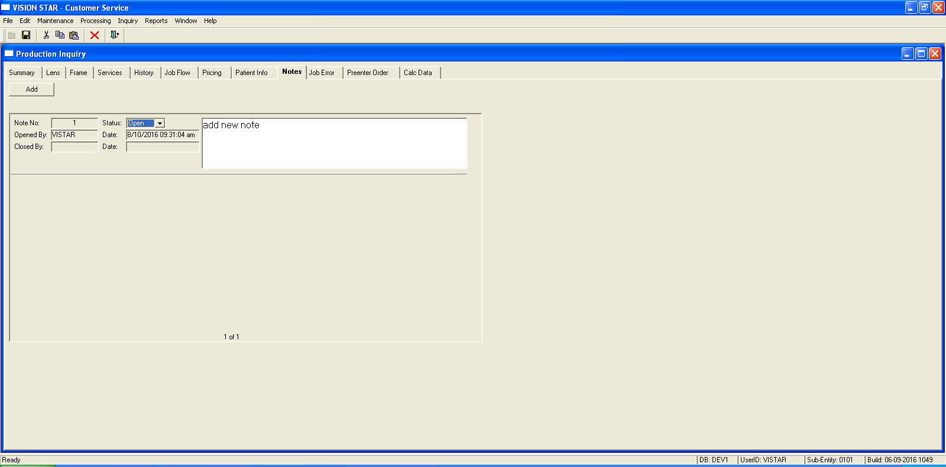

FP 27537 – In RX Order Entry, UD fields on RX Patient tab in random order
In RX Order Entry, on RX Patient tab, UD fields did not following display order setup in the contract tab of customer profile. This issue has now been resolved.

FP 27579 - Extract Date added to vlm_job_sum_extract
Added extract_date to the vlm_job_sum_extract so the actual date and time of extract can be included for Order Data Extract from System Management.

FP 27719 & 27117 - Allow an outsourced job to move to stations marked "ok to outsource"
In Production Management/ Maintenance/ Job Tracking/ Department Maintenance, a new flag called "OK For Outsourced" has been added. When this flag is set, these stations are available for selection for outsourced orders in Customer Service, bar code scanning and manual order tracking. This feature can allow the lab to change stations on jobs that are outsourced and allow tracing or retracing of job while it is outsourced. This feature is necessary for the auto recalc on retrace.

FP 28057 – Pricing Add On / Service tab amount column.
The amount field now accepts values greater than $999.99.

FP 28668 & 28672 – Invoice Discount List Maintenance window
INV Discount schedule maintenance window will now save discount schedules when no user defined fields are assigned to the schedule.

Patch Builds

Corequisites:

Accounts Payable Build 01-29-2013 1319
Accounts Receivable Build 05-11-2016 2356 *** new
Anti-Reflective Coating Build 01-30-2013 0959
Contract Management Build 04-15-2015 1213
Customer Service Build 05-12-2015 1208 *** new
Database Management Build 06-23-2016 1249 *** new
General Ledger Build 03-07-2016 1457
Inventory Management Build 03-08-2016 1951
Order Management Build 05-12-2016 0857 *** new
Production Management Build 05-12-2016 1010 *** new
Shipping Management Build 05-12-2016 1044 *** new
System Management Build 05-12-2016 1122 *** new

