p160304v1

FP 26574 – Hidden fields suppress copy on Copy Job and Remake job
When orders are imported from VisionWeb certain fields are being collected. They are specific to the order and should not be copied to a new order for either Copy or Remake job options. The fields are trx_no, third_party_guid, remote_sales_order_id, application_id.

FP 26341 - Zeiss Digital Calculator Ehancement
Zeiss has requested and added a tag for LMS to send the tray number in the job to the digital calculator. In order to implement this option the “zeiss” ldi file will need modified to include the new tag (TRAY).

FP 26195 – VisionWeb Outsourced status updates
VisionWeb has a status update feature that can update the history or an order that was outsourced. This is not supported widely across their network. When LMS receives the status and it is linked to a station the system will now just update history but leave the actual station to the outsource stations that is specified in the outsource vendor screen.

FP 25860 – Services on a single eye for a 2 eye job
In issue was reported where jobs where both lens status are DRESS but a service will only be applied to 1 of them, it was incorrectly applying to both eyes even after the user specified R or L on the service. LMS now correctly handles this situation.

FP25814 – Machine Interface support for VCA tags PHOTO, LTYPEB and LTYPEF
Some lab equipment can now support PHOTO, LTYPEB and LTYPEF tags. This required adding these tags to the equipment interfaces. This is now available for any machine that requests it.

FP25783 – Data Extract Format Maintenance
In data extract format maintenance in the data tab the fields on the left hand side would be removed from the list when the field was added to the right hand side making in unavailable to attach multiple times. A few different customers have asked if the field could be extracted multiple times in the same file. This was always possible but Customer Service had to manipulate the columns behind the scenes. Now the user can manage the columns. When the user adds a column to the right hand side now it is highlighted on the left and is still available if needed.
Add you add fields to the right the field on the left will highlight. 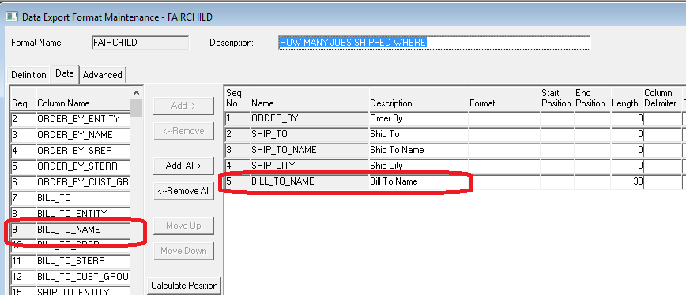

Below you can see I have added a few fields and clicked on the BILL_TO_NAME to add it to the right again.
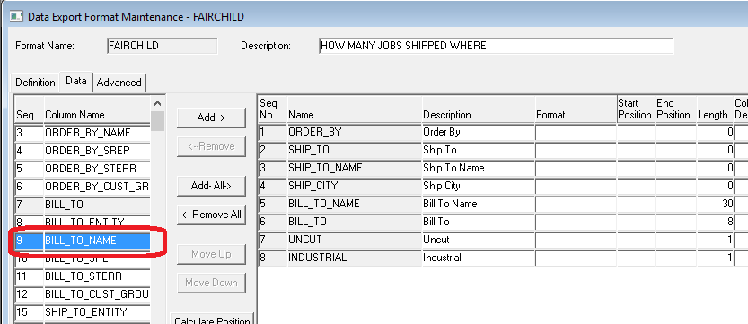
After clicking add you can see that BILL_TO_NAME is now on the right hand side 2 times.
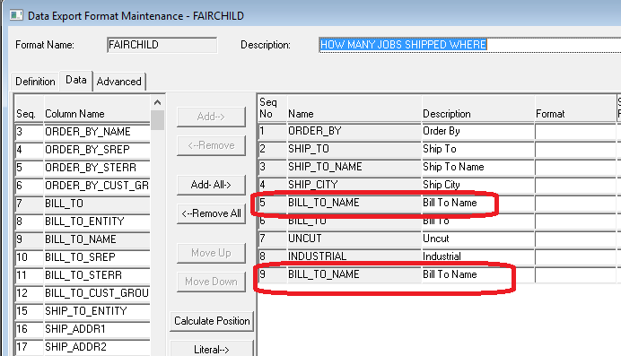

FP 25656 – Trallar Extract multiple AR RECORDS
We resolved an issue where in the Trallar extract. Multiple AR records would get extracted when a lens was digital. This has been corrected.

FP 25512 – Outsource Additional Data
In the Outsource Vendor Screen | Additional Data tab new options have been added. This will effects the VisionWeb outsource option. These options are “entered material, used material, entered lens style, used lens style and services”. The user can select the label for each of these to coordinate with VisionWeb.

FP 25397 – EYEMED Order extract Entered / Ordered lens material
In some cases the entered lens material was not found in the translation and reporting PCLR. The function that does the lookup has been corrected to find the entered lens material. If for some reason the mapping isn’t present for the material the job will be rejected from being sent. This is caught by VisionStar on a reject report for the Trallar file and normally corrected and sent later.

FP 24844 – Error with Split Pick item type option
An issue was identified where when the split pick flag is set on an item type in the System Options that the department maintenance require verify flag for that item type would not do the check. The scenario was split pick was turned on for frames. When split pick is on it does 2 things:
1. It changed the behavior of the Verification screen. As a user scans product into the verification screen once all “Non-Split Pick” items are scanned the screen will clear.
2. The require verify check is turned off for that item. The Mailroom / Shipping check for verified items still worked.
This functionality has been changed. It will only do part 1 above and leave part 2 the way it works for “Non-Split Pick” items. Meaning the department maintenance require verify flag will be the only thing used to decide if a station in the department can be used.
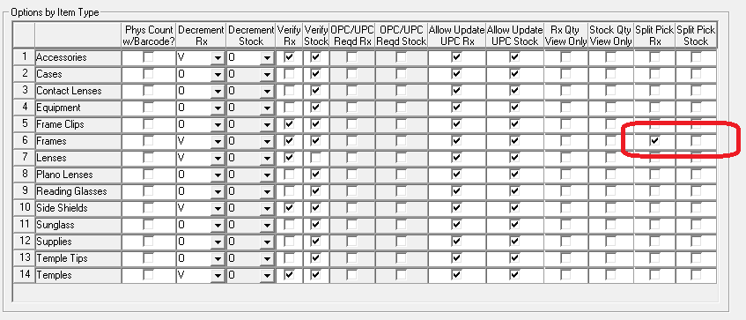

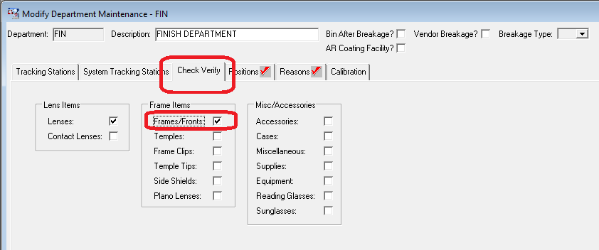

FP 24843 – Lab Identifier for All Applications
A system option is available that will turn on the option to put the lab name in the title bar of the application. It was initially developed only for the customer service application. This is now an option in all of the applications.
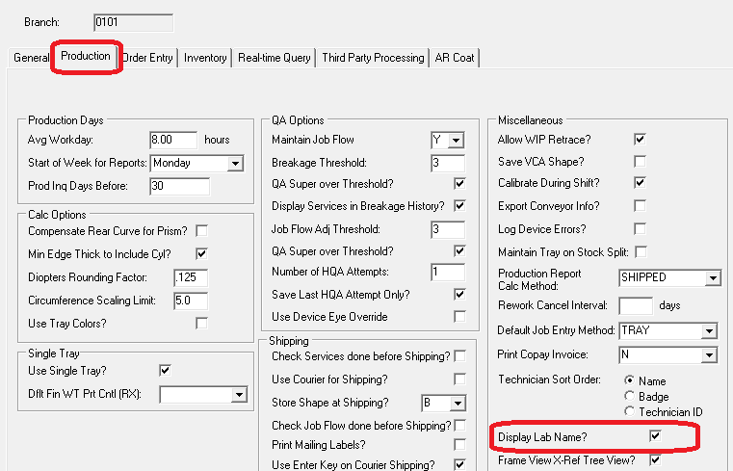
You can see that the name in the system options general tab is displayed in the title bar.
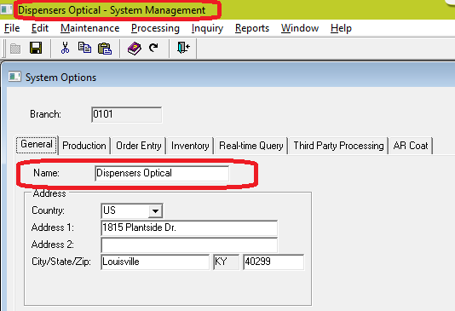

FP 24303 – UPS WorldShip Integration
The system now integrates with WorldShip for single job shipments. In order to implement a WorldShip computer and printer will need provided by the lab. The basic configuration requires attaching a WorldShip EDI control and ship service level to a ship method. The EDI control is used to specify what directory the shipping file will be placed. This file is picked up by WorldShip to create the shipment and label. The Shipment Service Level are the specific codes that WorldShip requires to know what shipping method is requested. These are values like 1DA for Next Day Air or GND for Ground. WorldShip also provides a return file that has the tracking number for that order. This is imported automatically and will update the order when received. This can be viewed in Customer Service in the services tab the tracking number field and also available to export back to ERP or VisionWeb in stations messages.

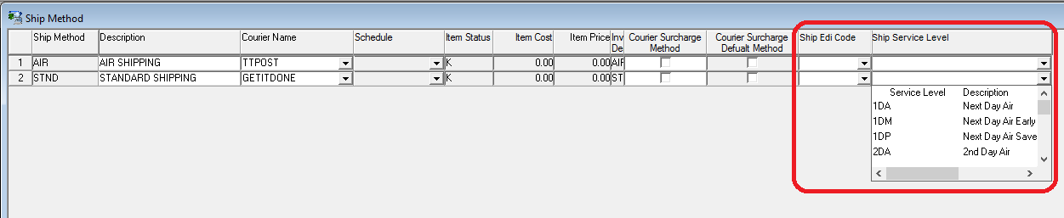

In addition a new option has been added to the customer profile | shipment tab. I check box called mail to patient has been added. This means that 2 ship methods can be assigned to a customer. One for regular shipments and a second for mail to patient.
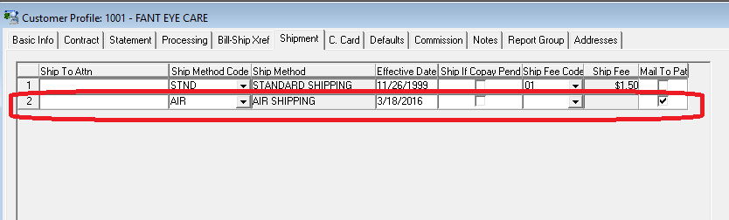
This changes order entry. Now in RX order entry in the patient info tab a ship method is available and when the user clicks the mail to patient check box or an order is imported as mail to patient the job will automatically switch to that mail to patient ship method if specified in the customer profile. If none is specified it will use the regular ship method.
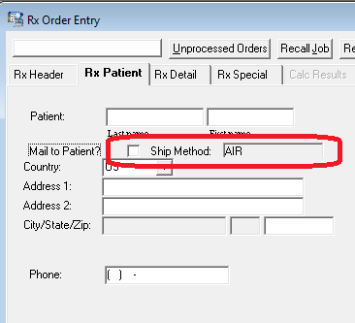

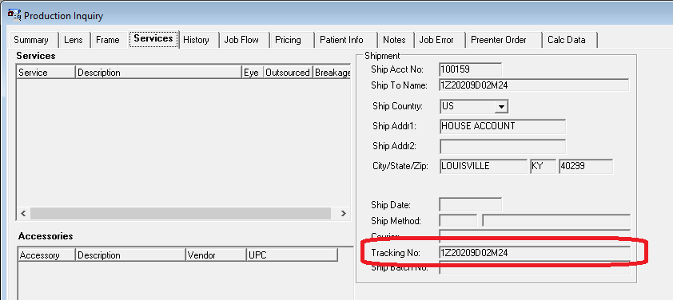

FP 24135 – Job Flow by Frame Status
Job Flow can now include stations associated to a Frame Status. This is similar to the way stations are associated to a service. The stations are added to job flow in the same order as all other stations (sequence).

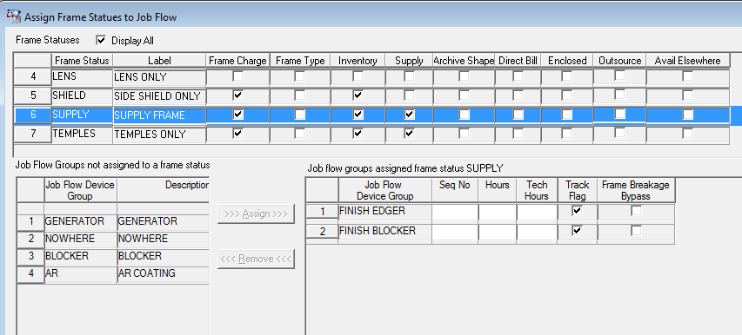

Patch Builds

Accounts Payable Build 01-29-2013 1319
Accounts Receivable Build 03-08-2016 1850 *** new
Anti-Reflective Coating Build 01-30-2013 0959
Contract Management Build 04-15-2015 1213
Customer Service Build 03-08-2016 1911 *** new
Database Management Build 01-12-2016 1757 *** new
General Ledger Build 03-07-2016 1457 *** new
Inventory Management Build 03-08-2016 1951 *** new
Order Management Build 03-08-2016 2025 *** new
Production Management Build 03-08-2016 2057 *** new
Shipping Management Build 02-17-2016 2117 *** new
System Management Build 01-20-2016 1249 *** new

