# p151116v1

### FP 25152, 25154 – Barcode Scanner program accepts Purchase Order and Print Label.

The Barcode Scanner program supports printing certain labels as setup in Department maintenance as manual order print control. The Manual Order Tracking and Manual order Printing screens have always support this and now the barcode program does as well. This will only work for labels that print from the other_label package. In order to activate this option the –MOT=OK option must be specified on the command line for the barcode scanners that will be enabled for this feature. Scanners can now be setup to scan and search for jobs either by job_id, tray or PO id. Previously scanners could only search either by tray or job_id.

### FP 25045 - Eyemed Entered v.s. Ordered Lens color

An issue was found in the Eyemed reporting where the lens color was not found and reported back to Eyemed a default color incorrectly. This has been resolved and now reports the correct lens colors for both entered and orders.

### FP 24727 – Outsource Comments Restriction Option

In 2013 Outsourcing was enhanced to allow transmitting comments to the Outsource Vendor through VisionWeb. When this was designed it sent all comments (1-4) on the job. The new option allows the vendor to be set to send the individual comments 1 through 4. For instance a vendor could be set to only send comment 1 and not the other 3.

### FP 24655 – Aspheric Single Vision Decentration changed

Decentration of Aspheric Single Vision Lenses has been changed not happen. This is to keep from inducing RX Prism in Aspheric SV.

### FP 24617 – VisionWeb Import Support for Industrial Thickness lens status

In VisionWeb import | Import Job Action 2 columns exist for regular and industrial lens status. This selection is based on the edge type sent in on the order. If the edge type is an industrial edge type based on the Industrial flag. The industrial lens status will be selected.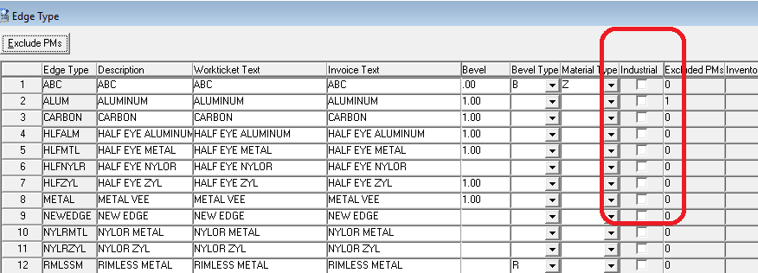

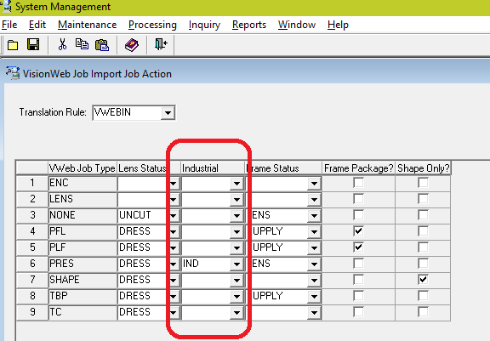

### FP 24438 - Print Direction by Customer Report Group

In System Management | Maintenance | Print Maintenance | Print Direction a print direction can be set by customer report group. This can have a big impact if you are currently using default services by customer to configure print direction rules you may be able to stop doing that and use the report group instead.

### FP 24435 – Makeability returns

Makeability now returns OPC’s correctly for the left lens.

### FP 24632 – Imported Invalid remake reason code returns

When an invalid remake reason code was imported with an electronic order the error code stored for the job was 0 and should have been 2263 as expected.

### FP 23629 – Statement to PDF

A new tab is available in AR Inquiry that can be used to generate a PDF of a statement for the customer currently selected. There is some setup that needs to be completed in order to make this work. It requires a Samba share connect and some directories on the LMS server and an entry in the vistar.ini file on each PC that will run this option. A statement can be printed for any past period for that customer. Aging is automatically done for the period selected. In addition the Monthly Processing screen has been enhanced to show the currently aged period so a user can decide if aging needs to be run again at statement time.

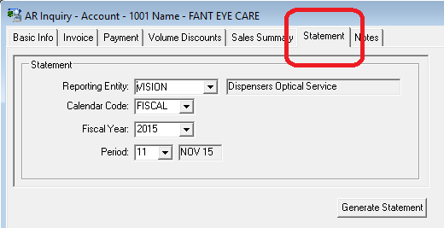

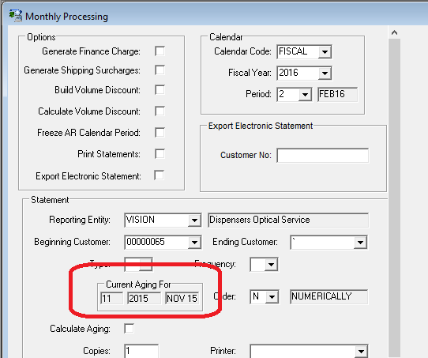

### FP 23431 – Essilor EYEZEN digital product support

Essilor EYEZEN digital support is available. EYEZEN requires a very specific lens setup as EYEZEN1, EYEZEN2 and EYEZEN3. Within each of these lens styles a new flag needs set in the lens style called Static Add. This is because the lens style is single vision but it requires an add power and seg height to be fitted.

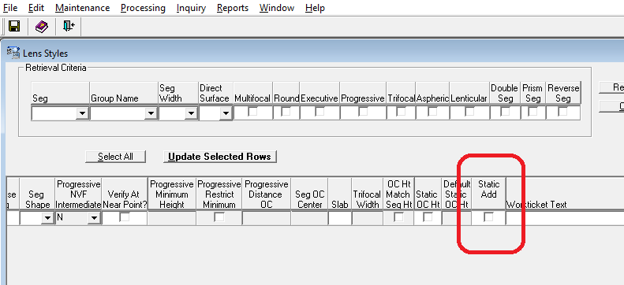

### FP 22749 – TDS Reporting

TDS – traditional digital surfacing has been enhanced with reporting in the Production Management | Inquiry | TDS Usage Inquiry. This report can be used to analyze the TDS throughput of the lab for either a specific order or a date range. This report looks at the historical data of actual tool usage and soft lap (TDS) selected due to no tool available or forced at order entry.

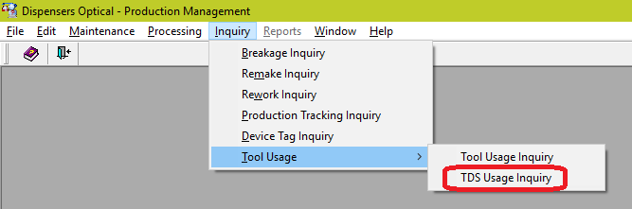

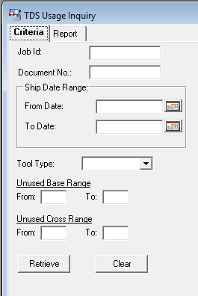

## Patch Builds

Accounts Payable Build 01-29-2013 1319

Accounts Receivable Build 11-05-2015 1443 * NEW *

Anti-Reflective Coating Build 01-30-2013 0959

Contract Management Build 04-15-2015 1213

Customer Service Build 09-23-2015 1257

Database Management Build 01-12-2016 1757 * NEW *

General Ledger Build 01-30-2013 1134

Inventory Management Build 08-26-2015 2039

Order Management Build 11-05-2015 2147 * NEW *

Production Management Build 11-04-2015 1926 * NEW *

Shipping Management Build 04-16-2015 0925

System Management Build 08-27-2015 1621