p150826v1

FP 23867 – Default Frame Dimensions on import
System Management | Maintenance | Import Rules have fields for B, ED and DBL for defaulting when these values are not provided by the remote order entry system. Some remote order entry systems allow users to skip these fields and this causes LMS to place the order in unprocessed orders until this data is provided. The system will default these values when provided on the import rule. The A measurement must be provided in order for this option to work.
The B field is populated with the amount to subtract from the A measurement to supply the B amount. For instance if this field is set to 10 and the A that is provided is 56 the B on the job will be 46.
The ED field is populated with the amount to add to the A measurement to supply the ED amount. For instance if the field is set to 4 and the A that is provided is 56 the ED will be 60.
The DBL field is populated with the exact DBL that you would like to default when not provided. For instance if this field is populated with 19 the DBL for the order will be 19.

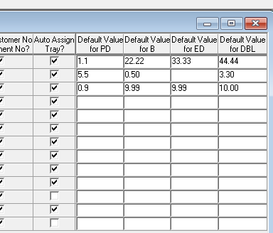

FP 23866 – Default PD inset (near pd)
System Management | Maintenance | Import Rules has a field Near PD for defaulting when this value is not provided by the Remote order entry system. LMS requires a Near PD for all multifocal lenses that are not progressive. This causes LMS to place the order in unprocessed orders until this data is provided. The system will default these values when provided on the import rule. The entry must be entered as a value for ½ of the near PD to default. When a Monocular PD is imported the default will be subtracted to create the full PD. When a Binocular PD is import the default will be multiplied by 2 and subtracted to create the full PD. For instance if the field is set to 1.5 and the Far PD provided is 32M the full PD will be 32M 30.5 for both eyes. If the field is set to 1.5 and the Far PD is set to 65B the full PD will be 65B 62.

FP 23865 – Slow Moving order by Lab schedule station time
The Slow Moving order by Lab report has a new column for scheduled stations. Scheduled stations are ones in Production Management | Maintenance | Job Tracking | Department Maintenance that have the Backlog field set to “S” Scheduled.

FP 23804 – Print Direction for Second Service
System Management | Maintenance |Print Maintenance | Print Direction has a new field for Service 2. This allows printer routing to be done on 2 services. For instance you can direct work ticket printing based on a Coating and a User defined service.

FP 23720 –Invoiced orders not transferred to AR
Zeiss Digital Orders that have warning or error messages that are returned from the digital calculator had an issue with invoicing. This has been resolved and these orders are now invoiced and transferred to AR correctly.

FP 23244 – Medicaid Billing 837 ICD 10 Support
Medicaid Billing supports ICD 10 codes. ICD 10 codes require a different qualifier then ICD 9 codes. All claims after 10/1/2015 are required to have an ICD 10 code. A default ICD 10 of Z460 will be sent. This can be overridden by providing a diagnostic code as a user defined field INS DIAG CODE (9007).

FP 23151 – GFM Customer Import Upper case city field
When importing Accounts electronically via the GFM XML the city field will be forced to upper case.

FP 22972 – Print Finish Work Ticket tray number lookup option
The Print Finish Workticket screen has an option to lookup an order via Tray and Job ID. It only worked with Job ID previously.

FP 22664 – Auto Outsource Rules Entered Prism
New attributes have been added to the auto outsource rules for entered prism from and entered prism to. The original prism_from and prism_to attributes still deal with total prism on an order. The new fields look specifically at prescribed prism only.

FP 22589 – Remote ASN VisionWeb
Remote ASN messages from VisionWeb will ship the order as long as the status is not shipped.

FP 22367 – Zebra Frame label new format
A new “frame to come” label has been created. It contains:
Job Id, Tray Number, Account Name, Patient Name, Frame Name, Frame dimensions and the last 2 digits of the job ID as a bin number.

FP 21952 – Crib to Ring Size for Services
Database Management | Processing | Service Create has a new button “Crib Ring”. This option is now available for coating and tint services. When a service is selected and the crib ring button is selected a screen is displayed to provide crib ring sized for that service. When this service is added to an order the cribbing will crib up to the next nearest ring size provided for that service.
Example: STANDARD AR Service
Ring sizes 50, 60, 70.
The job calculates as a 58.5 and has the standard AR service attached. The cribbing will be bumped up to 60 instead.

FP 21657 – Digital processing Price by cost based on selected blank
A pricing option is available called “price by cost” when this is selected it looks up the cost of the product and uses it as the price. With digital surfacing this was lookup up the cost of the digital lens itself and should have been lookup up the cost of the digital blank instead. Pricing now does this lookup to provide the cost of the blank as the price for the lens.

FP 21621 – VisionWeb Import force UNCUT order to pull semi-finished lenses
System Management | Maintenance | VisionWeb Import | Job Import Action has a new field force uncut. This field has 3 options Finish, Semi-finish or Do Not Force. When set to either S or F the order will force that type of lens to be pulled for the order the same way that it does when the lens type is specified in order entry.
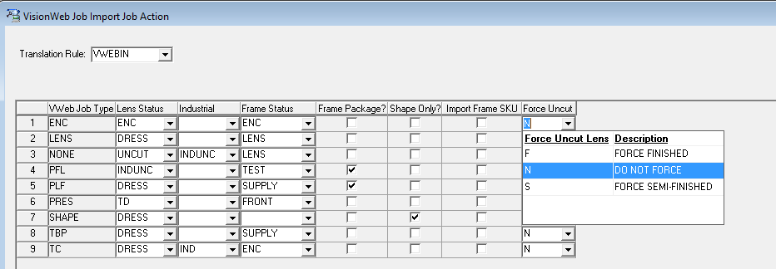

FP 20350 – Varilux S series Calculations for Single Eye RX
Even though Varilux S requires both lens prescriptions to calculate a single eye can now be requested and calculated. Half-pair Varilux S can now be calculated if prescription data entered also for the non-produced eye, along with a lens-status that has calculate_lens = N and enclosed = Y. (DEO requires DO=B, which, for a lens-status where calculate is N, can only be sent if enclosed is Y).

FP 20339 – Zeiss Digital Ticket extract on Import
Zeiss digital provides a PDF file that can be printed and sent to the ECP with the job when complete. This file was not reliably being extracted. This is now resolved.

FP 20038 – Essilor Stats report to Include Transitions Statistics
The Essilor statistics report can include Transitions Data as required by Essilor. Some configuration needs to be done in order to configure the report correctly. Contact VisionStar Support for configuration details.

FP 20012 – User Defined Fields for Discount Schedules
User Defined fields can be configured for Discount Schedules. When a user defined field is attached to a discount schedule order entry will prompt for the field data when the discount schedule is selected in the Rx Detail tab.

FP 18012 – Allow Cut jobs on Dims from Import
An option has been added to allows imported order for complete (dress or industrial) to calc on dimensions alone even though the system option for cut job requires shape is set to Yes. This is an option in import rules.

FP 15364 – Outsourcing of un-selected services fixed
Outsourcing had an issue with including services that have not been selected to be outsourced. This now works correctly and will only send services that are selected in the outsource screen.

FP 12137 – Job Flow machine interface and eye to call up after a breakage
When job flow is turned on and a breakage is posted for 1 eye the equipment was recalling both lenses. Now the system will set a flag for the machines that should pull up the single eye. In some cases this doesn’t always work out correctly. A new screen is available in production management that will allow a user to set the machines that should pull up 1 eye or 2 so it can be adjust manually.

Patch Builds

Accounts Payable Build 01-29-2013 1319
Accounts Receivable Build 08-26-2015 1833 new
Anti-Reflective Coating Build 01-30-2013 0959
Contract Management Build 04-15-2015 1213
Customer Service Build 09-23-2015 1257 new
Database Management Build 08-26-2015 1931 new
General Ledger Build 01-30-2013 1134
Inventory Management Build 08-26-2015 2039 new
Order Management Build 08-27-2015 1415 new
Production Management Build 09-23-2015 1544 new
Shipping Management Build 04-16-2015 0925
System Management Build 08-27-2015 1621 new

