p150409v1

FP 23071 – Specified Base Curve Support for Ideal Fit
Some jobs received a calculation error with a message that Specified Base Curve was not supported. This is now corrected and will only be displayed when the lens style flag is set accordingly.

FP 22413 – Lens Selection Control loosing AR Services
When Lens selection control had multiple sets to select between the AR services would get lost. Services now stay on the job with multiple sets correctly.

FP 22307 – Courier Shipping errors stopping shipping all other jobs
Courier shipping would stop shipping when a job failed to ship. This was causing the sales reports to be off from what was actually shipped. This was fixed so when a job fails to ship it doesn’t stop the process. This job will fail but all other orders will ship as expected.

FP 22243 – Cash Application Report Sorting
The cash application report will sort by customer number

FP 21933 – Job Flow Multi lab support
Job flow was found to not work correctly in a Multi lab environment. This is resolved and work correctly in this environment.

FP 21845 – Digital Calculation Required Fields Issue
PANTO and ZTILT was being treated as required in all cases even when the required fields screen was not set as required. This now treats these required data elements correctly.

FP 21721 – Eyemed Orders losing indicator
When an Eyemed order was recalled into order entry the eyemed indicator was being lost. This has been resolved.

FP 21688 – Product Barcode Printing for stock orders
The printing of frame and accessory barcodes for stock orders has been activated in both stock order entry and as a batch print in database management.

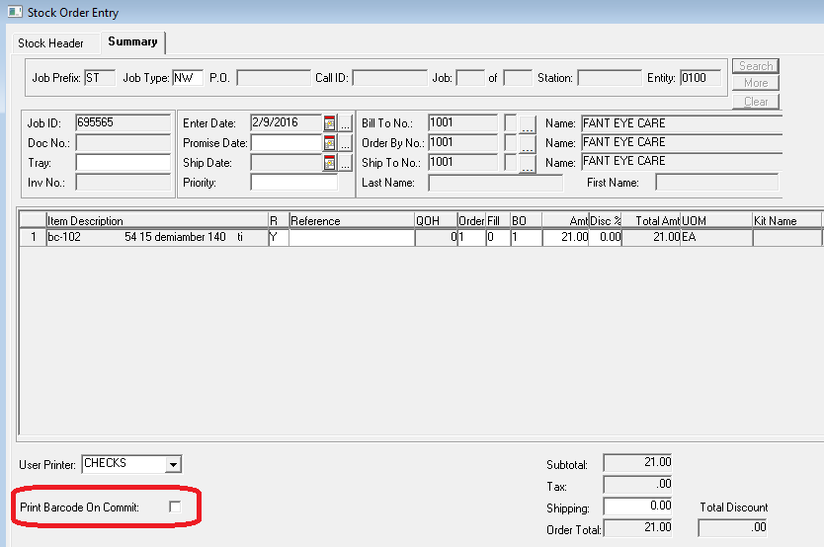

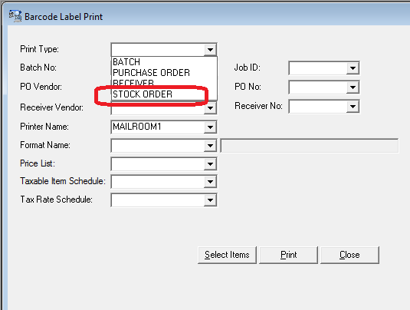

FP 21516 – VisionStar XML Send OC_HEIGHT when specified
In the VIsionStar XML when the OC Height is specified on the order and the job is outsourced the OC Height is now included in in the XML.

FP 21447 – VisionStar XML Import add support for Remote Salesperson
In the VisionStar XML schema the element <REMOTE_SALESPERSON> has been added for a retail system to send in the salesperson that is dispensing the order. This is displayed in customer services | Production inquiry and can be printed on the work ticket.

FP 21267 – Unable to assign a tray at Outsource Return
The Outsource Return Screen has been modified to allow a user to assign a tray number to a job when the tray required system option is set to Order Entry or Verify.

FP 20814 – Added Patient Phone number to svlm_job_sum_extract
The user defined fields for patient information have now been included in the ud_field 1 – 10 options in the data extract view svlm_job_sum_extract.

FP 20790 – Makeability calculations Include OPC for all lenses evaluated
In the makeability calculation the return XML includes all of the OPC’s evaluated by the RX Calculator.

FP 20717 – Automatic Options for Variliux Report and Essilor Digital Reports
New options have been added to the lens report group screen to turn on the option to automate the Varilux Statistics report. This requires configuration of the scheduler by VisionStar as well. The Essilor Digital Report can also be automated in the schedule by VisionStar. Please Contact customer service if you would like to activate either of these reports.

FP 20623 – TDS Traditional Digital Surfacing
A new option for tooling has been added. This has been called Tradition Digital Surfacing. The basic option allows tool schedules to be defined in the system. These tools schedules can be attached to any lens option (Production Management | Maintenance | Laboratory Standards Lap Locations). When a job is calculated for this lens option and tool schedule the system will calculate the tool needed. If it is found in the schedule the system will use that tool and calculate as traditional. When the tool is not found the system will calculate the order as a digital (soft lap processing).
The Tools screen in Production Management has changed to include a schedule name and TDS check box.

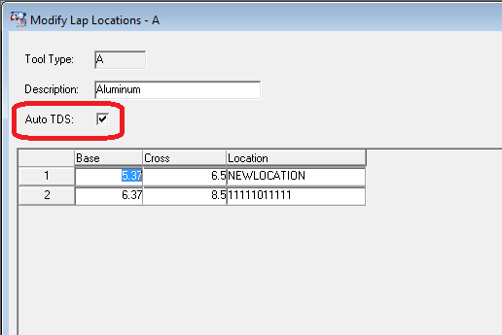

FP 20584 – Eyefinity Import Orders include Frame Color
The Eyefinity import now keeps the frame color that was sent in on the order for Enclosed or Frame to Come.

FP 20882 – Copy Pricelist Screen doesn’t copy schedules
The copy price list screen stopped copying schedules when selected. In the release the user will be prompted for a description and effective date for each schedule that is selected and the new schedule will be copied from the selected schedule.

FP 20518 – Print Direction by User for Purchase Orders and Receivers
In the user profile section of user maintenance new options have been made to set a user printer for purchase order printing and receiver printing.

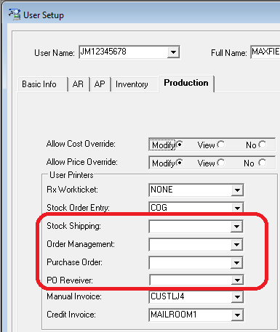

FP 20475 – Shape Import Improvements
Improvements have been made in the job import process to detect and import shapes that have format issues. It was found that some shapes that are received via Electronic import may be missing <CR> and/or <LF> characters on some lines. This is now detected and corrected during the shape store process.

FP 20467 – Data Extract Format svlm_job_sum_extract added columns
The following columns have been added to the view svlm_job_sum_extract to provide more data for RX orders.
- Order Time – provides order time down to the second HH24:MI:SS format. (i.e. 16:15:21)
- Ship Time – provides ship time down to the second HH24:MM:SS format
- Digital Surface – A Y/N field indicating if the job is digitally surface. Y is digital / N is traditional
- AR_Coated – A Y/N field indicating if the job had an ar coating service on it. Y has AR / N does not

FP 20332 – Logging Issue on Import Verify process
The import Verify process failed to create a log file. This issue has been resolved.

FP 20264 – Essilor Digital Interface LaserOp issue
When a LaserOp laser is used in the Varilux S series process the information the Laser needed was not being sent. The issue was resolved by changing how the LDPATH is read for the LaserOp laser in the digital communications data sent from the Essilor Digital Interaface.

FP 20199 – Remote Invoice ID Functionality (VisionWeb)
The system can now import a new data point from VisionWeb called Remote Invoice Id. It comes in through an XML element. HEADER/DELIVERY/InvoiceNum. This is stored with the job and available in the svlm_job_sum_extract view in the Data Extract Maintenance window.

FP 20195 – Shape Import Improvements Circumference
It was found that some tracers don’t provide an appropriate CIRC value that cause shapes to not be stored on import with a job. When the FIL packet contains either *no* CIRC=.... record, or a CIRC record with a question mark for one of the values, eg "CIRC=?;xxx.xx". Note "CIRC=;xxx.xx" is fine. The shape import can handle this situation correctly.

FP 19951 – Production Management Sort Order
The production management report now sorts the customers correctly when run on an Oracle 10 database.

FP 19926 – VisionWeb import support for LENS ONLY option
VisionWeb now support a job type called LENS ONLY. The concept is to allow an order where the customer is sending the jobs without a shape or frame and wants the production lab to supply completed (edged) lenses based on a shape they lab should already have. A new value of LENS has been added to the JOB ACTION TRANSLATION screen in System Management | Maintenance | VisionWeb Export. The lab will need to translate the new entry to the appropriate lens and frame status for this type of job. This is normally translated to DRESS for the lens status and LENS for the frame status.

FP 19950 – Unbin order by tray number
In the Unbin Screen add the ability for the user to look up the order by tray or by Job ID. Originally only able to look the order up by Job ID.

FP 19586 – Remove Job from a Job Bin before recall / recalc is allowed
In the Order Entry screen when a job is being recalled that is currently in a Job Bin stop the user from recalling it with a message that the job must be unbinned before it can be recalled.

FP 19070 – Shamir Digital Reporting Changes
Shamir has changed the format of their electronic report.
- The report is now in a csv format and requires a csv extension
- If and OPC is not available for the reported product the lens description is used in its place
- Format: Invoice Date,InvcNo,ShipToAcctNo,ShipToAcctName,Addr1,Addr2,City,State,PostalCd,
PhoneNo,LensOPC/Description,LensNetUnitQty,Redo(Doctor),Redo(Lab),Redo(Warranty)
,Redo(Non-adapt),Subcontracted Lenses,Coating code AA1 Unit Qty,Coating code BB2
Unit Qty,Coating code CC3 Unit Qty

FP 17935 – MicroLab / Pre-blocked Lens processing
LMS has the capability to produce pre-blocked lenses for use in manufacturing and use pre-blocked lenses in the manufacturing process. The system can also produce purchase orders for pre-blocked lenses that can be imported as a stock order. The concept we call microlab where a Laboratory will pre-block lenses on a machine in house and those lenses would be used at a satellite lab where a surface blocker is not used only a generator for surfacing lenses. The lens detail screens have been modified to have the fields required for pre-blocking specifically the stack height, prism angle, prism amount and a reference to the original lens that was blocked. The process for blocking is done using the calibration option in VisionStar. This allows multiple copies of the same lens to be produced from a single order. In the Microlab the pre-blocked lenses are created and the information (stack height, prism angle, prism amount) are added. These lenses are then used as the blanks in the digital lens process at the microlab. Since the usage of these preblocked lenses is tracked at the microlab purchase orders can be created for these products and sent electronically to lab that produced the pre-blocked lenses for replenishment.

FP 13171 – Outsource Report Error Message Expansion
In Inventory Management | Report | Outsource Report. The error message received from VisionWeb when an order failed was being truncated. This is now corrected and the entire message is available on the screen.

Patch Builds

Accounts Payable Build 01-29-2013 1319
Accounts Receivable Build 07-02-2014 1413
Anti-Reflective Coating Build 01-30-2013 0959
Contract Management Build 04-15-2015 1213
Customer Service Build 10-17-2014 1300
Database Management Build 04-15-2015 1349
General Ledger Build 01-30-2013 1134
Inventory Management Build 04-16-2015 0848
Order Management Build 04-15-2015 1018
Production Management Build 01-29-2015 1320
Shipping Management Build 04-16-2015 0925
System Management Build 12-03-2014 1426

